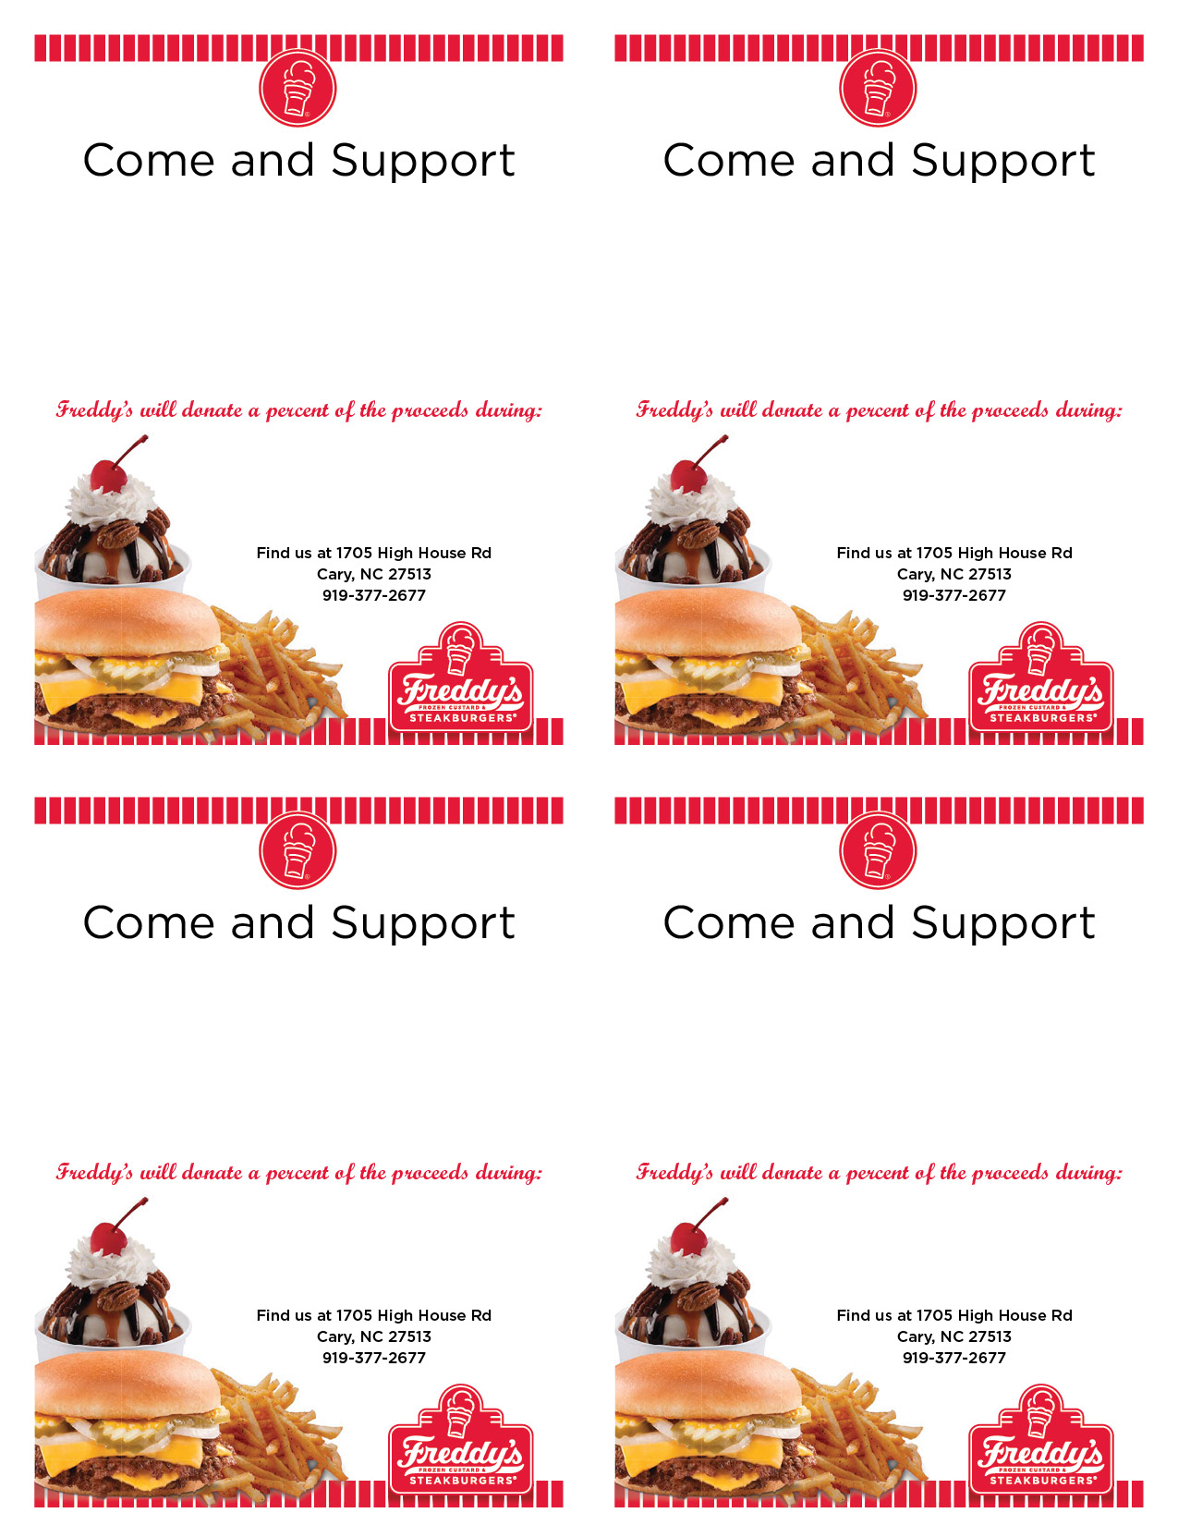­­­

Donation up to 25% depending on # of guests

Donation up to 25% depending on # of guests

Donation up to 25% depending on # of guests

Donation up to 25% depending on # of guests

03/29/16 – 03/30/16

5:00 p.m. – 8:00 p.m.

03/29/16 – 03/30/16

5:00 p.m. – 8:00 p.m.

03/29/16 – 03/30/16

5:00 p.m. – 8:00 p.m.

03/29/16 – 03/30/16

5:00 p.m. – 8:00 p.m.

The class with the most participants will win an ice cream party! Please remember to sign in for credit.

The class with the most participants will win an ice cream party! Please remember to sign in for credit.

The class with the most participants will win an ice cream party! Please remember to sign in for credit.

The class with the most participants will win an ice cream party! Please remember to sign in for credit.

Carpenter Elementary

PTA

Carpenter Elementary

PTA

Carpenter Elementary

PTA

Carpenter Elementary

PTA